
IS6751 – TEXT & WEB MINING
Group Project
Sentiment Analysis Model Based on Twitter Comments

Wee Kim Wee School of Communication and Information
Semester I AY2024-2025

Submitted by:
Guo Kaihua (G2304650E)
Ren Xiao (G2405573L)
Zhao Xiajing (G2406086D)
Zhou Gaoqiang (G2304064A)

[word count: *]

Table of Contents
Introduction 3
Background 3
Research Objective 3
Data 4
Dataset Overview 4
Data Preprocessing 5
Dataset Review After Preprocessing 6
Methodology 6
Machine Learning Based Approach 7
Deep Learning – RNN Approaches 9

Introduction

Background
With the rapid development of social media, especially the proliferation of user-generated content on platforms such as Twitter (Zimbra et al., 2018). Compared with traditional news reports or blogs, comments on social media, as a form of real-time, language-rich, short-structured text, are more fragmented, instantaneous, and frequently updated, widely reflecting users' attitudes and emotions towards hot events, products and services. Users quickly express their personal opinions through short texts and become “sensors” of social emotions. (Ainley et al., 2021).
Sentiment Analysis, aims at identifying and extracting users' subjective emotions from natural language texts, which are usually classified into sentiment categories such as Positive, Negative, or Neutral. The breadth and openness of Twitter data provide rich resources for sentiment analysis research. Researchers and engineering practitioners can mine it for multi-dimensional information which can be applied to a wider range of applications (Sahayak et al., 2015).
However, due to tweet text's highly unstructured nature, such as common abbreviations, spelling mistakes, special symbols and even multilingual mixes. Coupled with the short text and limited contextual information, make traditional text categorization methods more challenging when dealing with Twitter data (Mohammad, 2017). To address this issue, researchers have started to introduce deep learning methods based on neural networks, such as Recurrent Neural Networks (RNNs), Long Short-Term Memory Networks (LSTMs), and Gated Recursive Unit (GRU) models. The accuracy of social media sentiment analysis has been significantly improved by using these methods (Yue et al., 2018).

Research Objective
The goal of this project is using machine learning and deep learning techniques to build a sentiment analysis model for Twitter comments, and compare the effectiveness through multiple approaches.
- Data Preprocessing: the raw Twitter texts are cleaned, segmented and denoised to construct a sentiment analysis dataset suitable for model training.
- Multi-model comparative Experiments: based on the preprocessed dataset, the following methods are used for sentiment classification modelling:
  - Machine Learning method: Logistic Regression.
  - Deep Learning methods: RNN based (Basic RNN, LSTM, GRU) , CNN.
  - Pre-trained Language Model: Bidirectional Encoder Representations from Transformers (BERT).
- Performance Evaluation and Analysis: the performance of each model on the test set is evaluated through metrics such as accuracy, recall and F1 score.

Data

Dataset Overview
This project used the Sentiment Analysis Dataset from Kaggle. It contains 1.6 million labelled Tweet text for sentiment analysis.
- Dataset Column Description
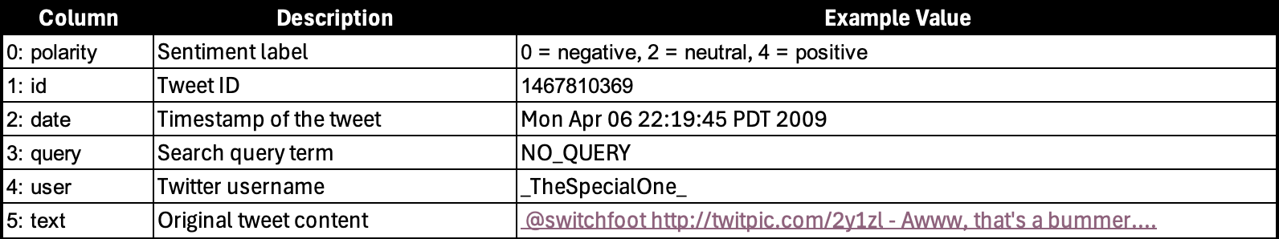
- Word Cloud
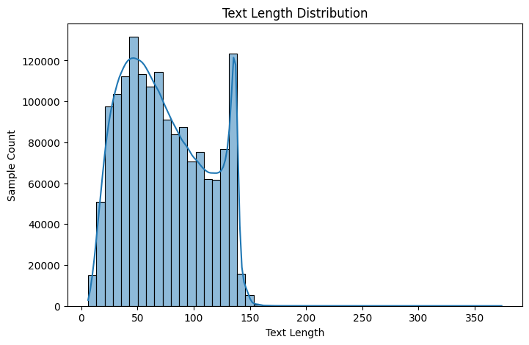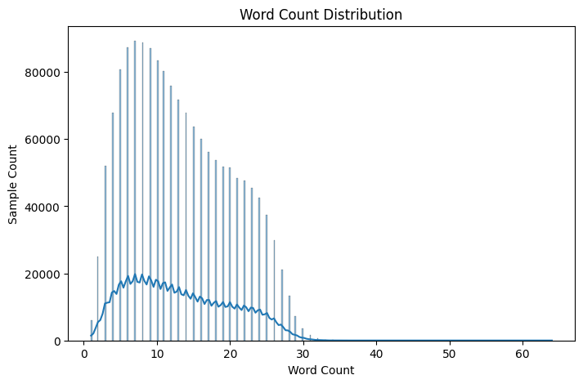
To better understand the dataset, we analyzed the distributions of text length and word count. We observed that most comments have a text length between 0-150, and the number of words is generally less than 30.
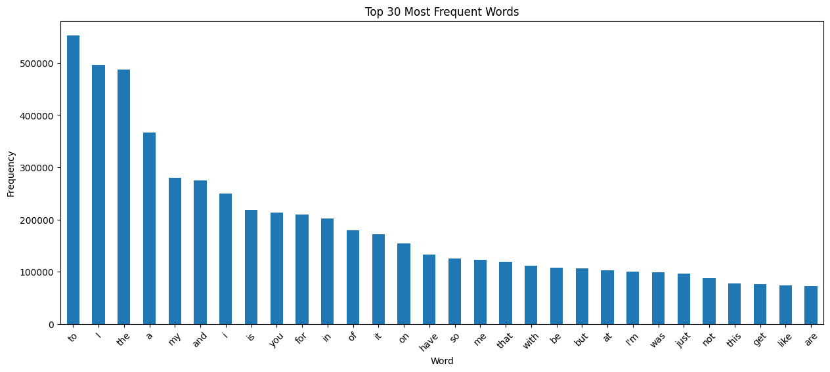
In addition, we extracted the top 30 most frequent words, but found that most of them are common stop words.
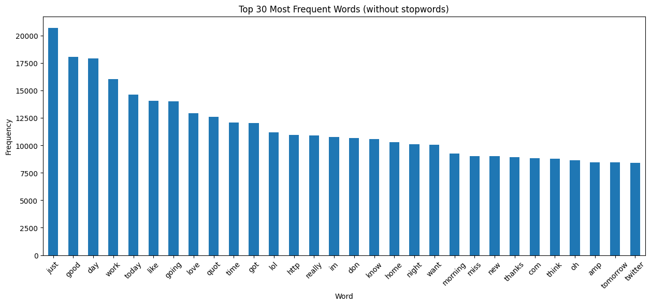
After removing stop words, the most common words are shown in the figure above.
- Class Distribution
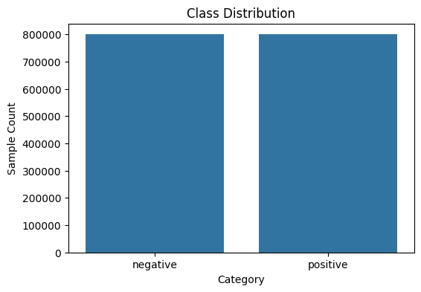
It can be observed that the dataset does not actually contain the label 2=neutral, so our classification task will not include this category. The remaining two labels, negative and positive, are perfectly balanced, indicating that the dataset is well-suited for binary sentiment classification.
- Examples
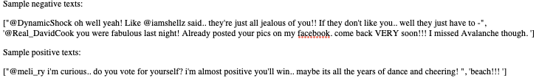

Data Preprocessing
Based on the dataset column description above, most columns are unrelated to sentiment analysis. Therefore, we retained only the “polarity” and “text” columns for our task.
To improve generalization and reduce dimensionality, additional data preprocessing approaches were applied. First, all HTML tags and brackets were removed. Next, abbreviations were expanded to their full forms. The text format like @someone and email addresses were also removed. Additionally, non-ASCII characters, including emojis and special symbols, were filtered out to maintain a clean and consistent text format for model training.

Dataset Review After Preprocessing
After completing data preprocessing, I reviewed the dataset and analyzed the proportion of infrequent words within the overall vocabulary. This was done to determine how many words to retain during training, as removing rarely used words can reduce noise, lower model complexity, and improve generalization.
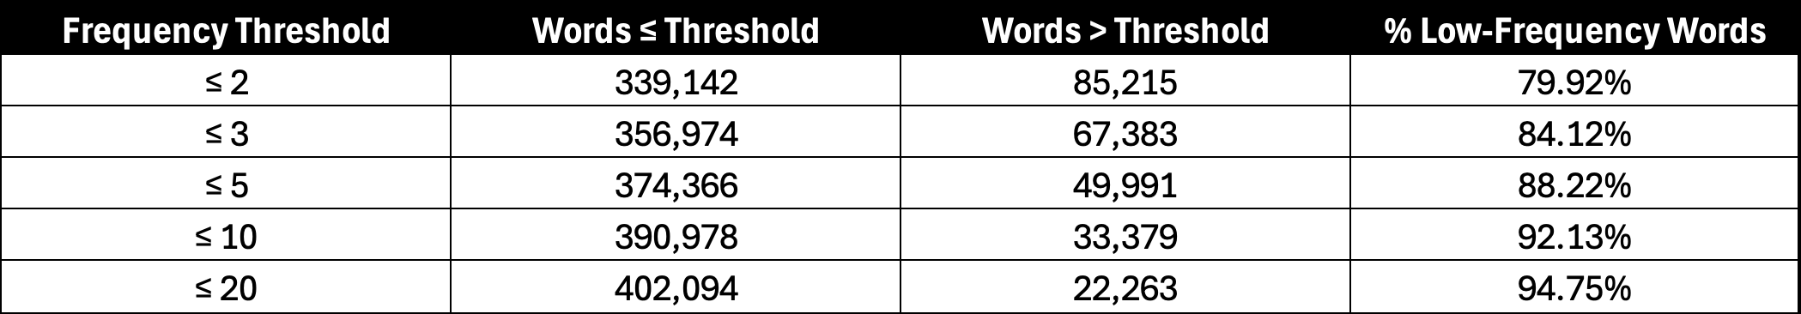
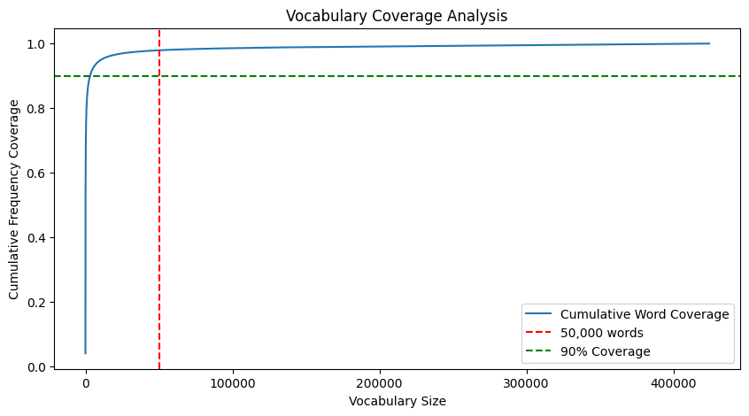
Based on the table and the chart above, if we hypothetically select the top 50,000 most frequent words, they will cover the vast majority of the text data. Each of these words appears more than five times, indicating that they are sufficiently representative and meaningful for training purposes while effectively reducing noise from low-frequency terms.

Methodology
This project built multiple different approaches to classify the sentiment of the text.
- Logistic regression (GeeksforGeeks, 2025) is a supervised machine learning algorithm used for classification tasks where the goal is to predict the probability that an instance belongs to a given class or not.
- A RNN (Graph, 2024) is a special type of ANN adapted to work for time series data or data that involves sequences. It is trained to process and convert a sequential data input into a specific sequential data output. Sequential data is data such as words, sentences, time-series data where sequential components interrelate based on complex semantic and syntax rules.
- A Convolutional Neural Network (CNN), also known as ConvNet, is a specialized type of deep learning algorithm mainly designed for tasks that necessitate object recognition, including image classification, detection, and segmentation. Beyond image classification tasks, CNNs are versatile and can be applied to a range of other domains, such as natural language processing, time series analysis, and speech recognition (Sharma, 2024).
- BERT is a Transformer-based pre-trained language model that understands deep semantic information in text by leveraging bidirectional context modeling. In this project, the DistilBERT version was utilized, as it retains the superior performance of BERT while reducing the model size.
The following is a flow chart of this project.
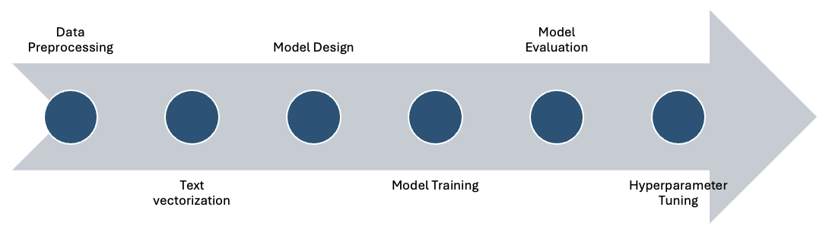

Machine Learning Based Approach
Due to the large size of the dataset, using logistic regression as initially planned resulted in high computational cost. Given the many tunable hyperparameters and optional preprocessing steps, it was challenging to efficiently explore and identify the optimal configuration.
To address this, I first adopted a Naive Bayes classifier, which is computationally lightweight, to fix certain behaviours and preprocessing strategies before applying more complex models. And the baseline setup included a variety of preprocessing configurations and TF-IDF vectorization options. Specifically, we experimented with:
- Whether to remove punctuation marks.
- How to handle numeric tokens: removing them, converting them to works, or leaving them unchanged.
- Common TF-IDF parameters such as n-gram range, whether to lowercase, maximum feature size (refer to dataset review), and whether to remove stop word.
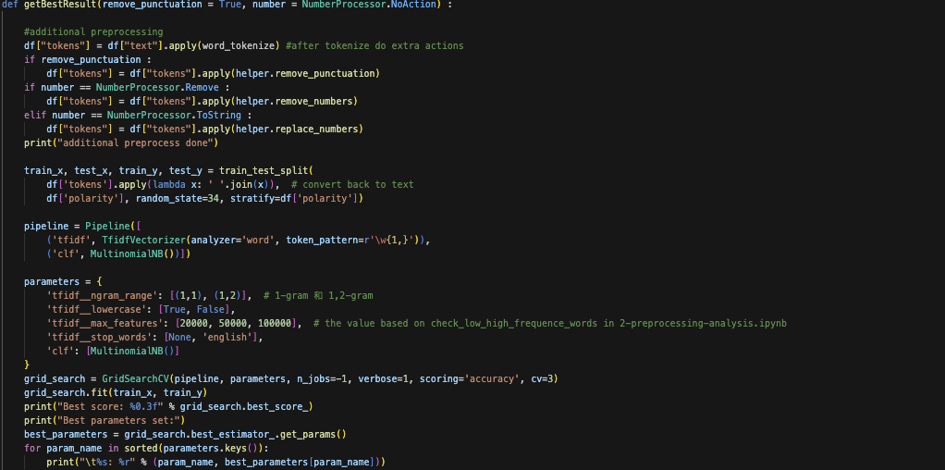
To identify the optimal configuration, we manually adjusted preprocessing strategies and conducted grid search over selected hyperparameters (refer to above code). The result performance under each combination is summarized as follows:
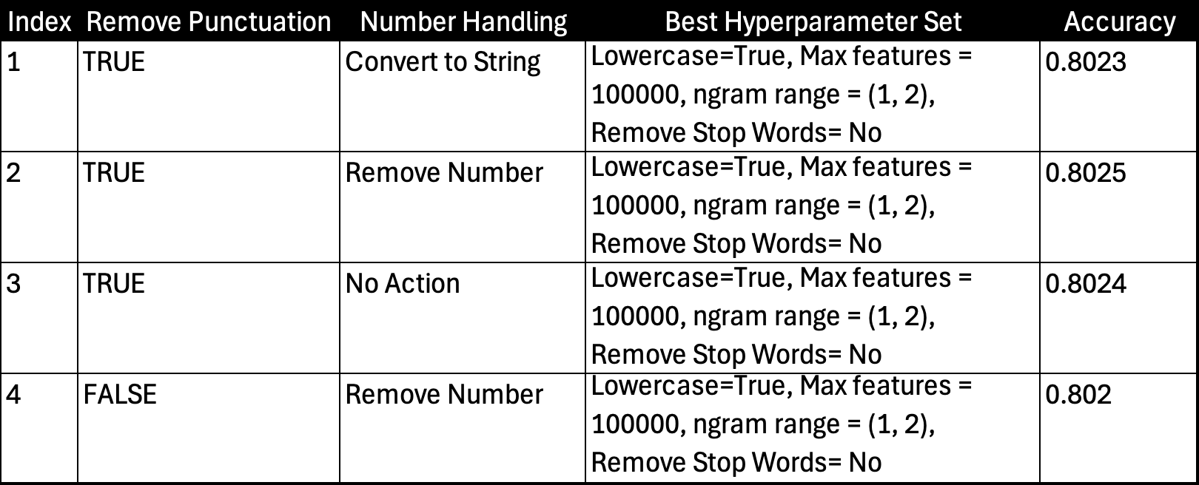
As shown above, different number handling strategies and the removal of punctuation had minimal impact on model performance. Given this observation, and to promote better generalization and reduce dimensionality, we chose to remove both numbers and punctuation in the subsequent stages. Additionally, the grid search consistently identified the same set of hyperparameters. Therefore, we adopted this hyperparameter setting and applied in directly to the upcoming experiments using logistic regression.
Then we proceeded to train the model using logistic regression, introducing an additional hyperparameter C, which controls the strength of regularization. This prevents overfitting and balances the complexity of the model. If the regularization is too weak (larger C), the model may become too complex and overfit the training data. If the regularization is too strong (smaller C), the model will be too simple and may not adequately capture the complexity of the data.
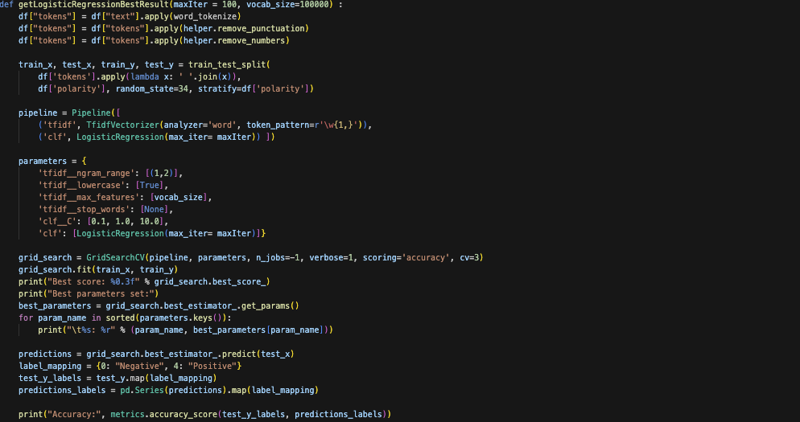
At this point, the best accuracy of the model is 0.823, and clearly indicating that logistic regression outperforms Naïve Bayes in terms of classification accuracy.

Deep Learning – RNN Approaches

Standard RNN
At this point, the best accuracy of the model is 0.823, and clearly indicating that logistic regression outperforms Naïve Bayes in terms of classification accuracy.

